ESP32 CONTROLLER PER QO100
https://github.com/apozzon/QO-100_RTX_CONTROLLER
 | QO-100 RTX |  |  |  | IP |  |  |  | SSID |  |  |  | PASSW
 | Controller |  |  |  | 192.168.0.214 |  |  |  | SKYAP2 |  |  |  | ************
 | ON/OFF |  | DATV |  | GPSDO |  | … |  | … |  | … |  | … |  | …
 | V in |  | V pow |  | A pow |  | mW in |  | W out |  | W ref |  | SWR |  | T air-pow
 | 13.8 |  | 27.5 |  | 1.5 |  | 10 |  | 7,5 |  | 0,6 |  | 1,78 |  | 19-33

Misure
Parametro | Max | PIN | Note
V ingresso | 13.8 V | 1 | Partitore 1:10
V potenza | 30V | 2 | Partitore 1:10
A potenza | 5A | 3 | ASC712-5A
W power in | 5V | 4
W power out | 5V | 5
W reflected | 5V | 6
C temperatura aria | 60C | 11 | DHT22
C P.A. | 60C | 10 | DB18S20

Controlli
Parametro | Stato | PIN | Note
On / Off | 0-1 | 7 | Accende e spegne SDR – Arduino sempre on low
DATV | 0-1 | 8 | Commuta 12V-18V su Bias-T
GPSDO | 0-1 | 9 | Accende GPSDO

ARDUINO - INSTALLAZIONE IDE E SETTAGGIO BOARD
Setup Steps for Arduino IDE
NB: se non carica support mettere queste due istruzioni in C:\Users\Andrea.DESKTOP-IK5K4JJ\.arduinoIDE\ arduino-cli.yaml
network:
connection_timeout: 300s
- Open Arduino IDE and go to File > Preferences.
- Add Board Manager URL: Paste the following into the "Additional Boards Manager URLs" field:
https://raw.githubusercontent.com/espressif/arduino-esp32/gh-pages/package_esp32_index.json
- https://github.com/ESP32Async/ESPAsyncWebServer

- Install Boards: Go to Tools > Board > Boards Manager, search for "esp32" and install the latest version by Espressif Systems.
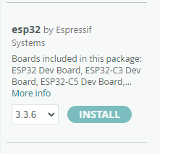

- Select Board: Select Tools > Board > ESP32 Arduino > ESP32S3 Dev Module.
- Configure Tools Menu (Crucial for N16R8):
  - USB CDC On Boot: "Enabled" (Allows Serial.print via USB).
  - Flash Size: "16MB (128Mb)".
  - Flash Mode: "QIO 80MHz" or "QOIO 80MHz".
  - Partition Scheme: "16M Flash (3M APP/9.9M FATFS)" or similar large partition.
  - PSRAM: "OPI PSRAM".
- Upload: Connect the board, select the correct Port, and upload a test sketch.

Installazione librerie
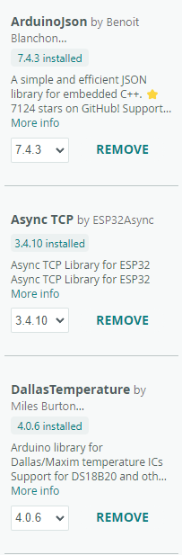 | 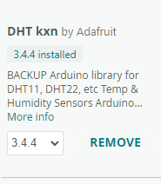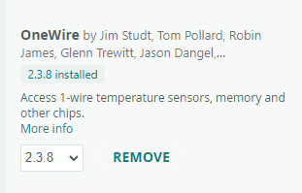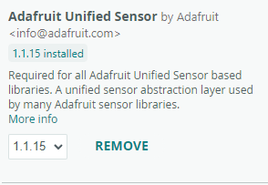

Vengono salvate nella directory di progetto
C:\Users\Andrea.DESKTOP-IK5K4JJ\OneDrive\RADIO\Autocostruzione\OSCAR-100\$ Programmazione\Arduino_ESP32\libraries
Si possono copiare nella nuova installazione chiudere e riaprire IDE che si caricano da sole.
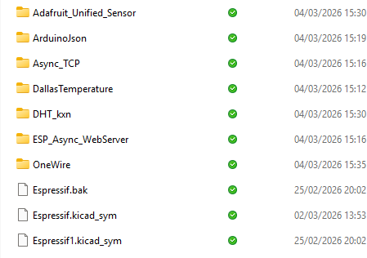

JAVA aggiunta libreria Google json
tasto destro su Progetto – Build Path -Add External Archives) – Scegliere file scaricato (es. gson-2.3.1.jar)

Compilazione
File -> Export
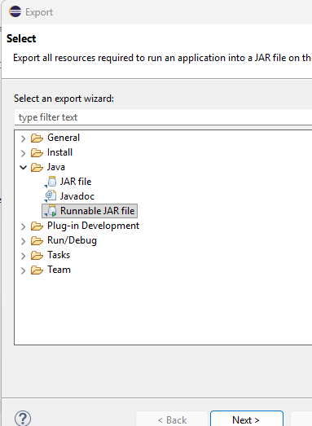

Launch4j
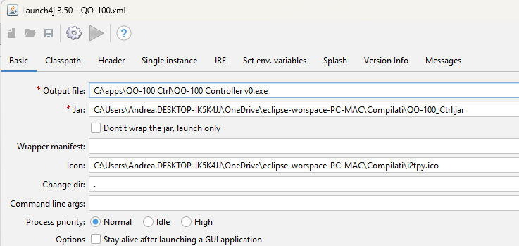
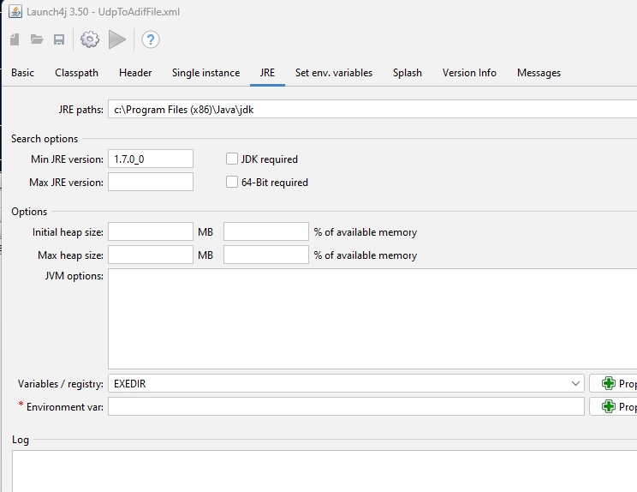

PER USO PROGRAMMA SERVE:
- JDK INSTALLATA IN "C:\Program Files (x86)\Java\jdk"

CONTROL BOARD
